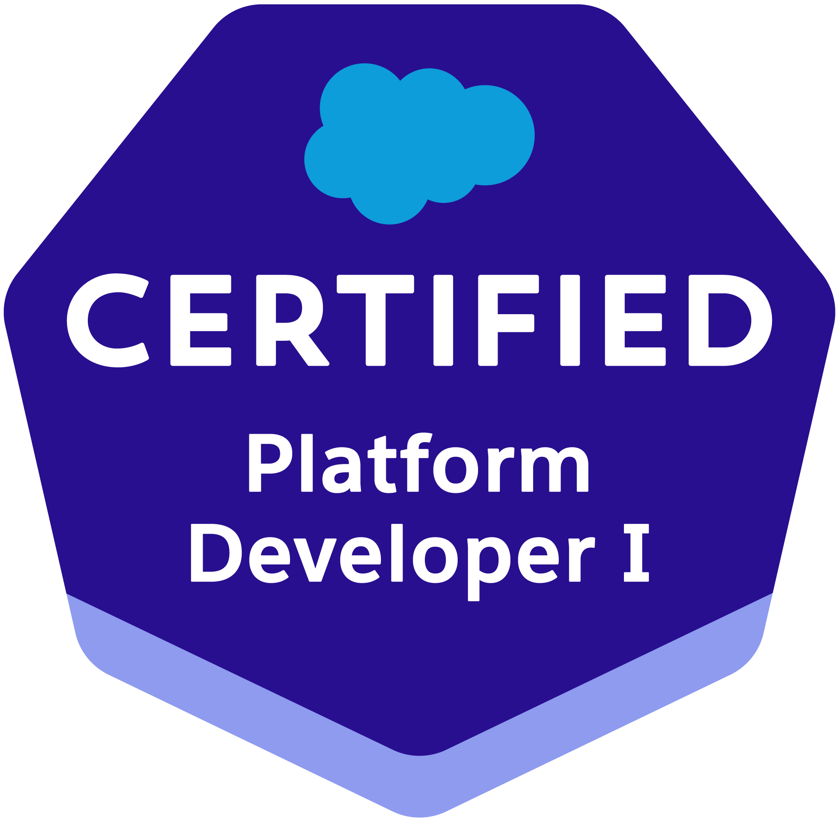

Nikhil Satpute
9607357648 | nikhilaksatpute@gmail.com | https://www.linkedin.com/in/nikhilasatpute | https://www.salesforce.com/trailblazer/amdit

PROFESSIONAL SUMMARY
Highly skilled and experienced Salesforce developer with a strong background in building and customizing Salesforce applications. Possesses expertise in various Salesforce technologies, including HTML, CSS, Javascript, Process Builder, Workflow, Apex (including Apex Classes and Apex Triggers), Lightning Web Component, and Visualforce. The candidate is proficient in data modeling, Apex Data Loader, and data migration. Possesses strong knowledge of SOQL and are skilled in building effective and informative dashboards and reports to help businesses make data-driven decisions.

EXPERIENCE
Salesforce Developer : Percept Infosystems Nagpur January 2023 - December 2023

- Designed and managed custom Salesforce solutions (objects, apps, fields, tabs, reports, dashboards) to meet business needs.
- Implemented Salesforce tools (Triggers, Workflows, Validation Rules, Apex, SOQL) for customization and automation.
- Developed custom Apex Triggers for lead assignment.
- Collaborated within an Agile development environment, Ensured project efficiency.
- Completed Salesforce Trailhead projects and committed to continuous learning. Adaptable to a fast-paced work environment.
- Performed 25 + debugging activities to solve errors in apex, triggers, and flows.

Associate RF Engineer: AMDOCS ,PUNE January 2022 - December 2022
- Developed and executed a comprehensive fiber network drafting strategy, resulted in a 25% reduction in drafting errors and a 15% increase in drafting efficiency.
- Orchestrated the implementation of ARAMIS, FTTx, and FTTH fiber planning systems, resulted in a 40% reduction in deployment time and a 30% increase in project completion rate.

Application Engineer: ARTEMIS PVT. LTD. ,PUNE October 2021 - January 2022

- Exhibiting strong technical aptitude and application expertise resulting in optimized performance, continuous improvement recommendations and product innovation.
- Partnered with the development team on product development and application support plans. Visited clients to determine feasibility, analyze requirements and provide solution suggestions.

Technical Qualifications

- Programming Languages: Apex programming,OOPs, Visualforce.

Database: SQL Server, SOQL, SOSL, SQL, DML .
- Web Technologies: HTML, CSS, JavaScript.
- Salesforce Technologies - Apex Classes, Apex Triggers, Asynchronous Apex, Workflow Rule, Approval Process,

Process Builder, REST API, Lightning Web Component, Report & Dashboard & Salesforce Lightening Flows.

PROJECTS

- Ms Amlin insurance
  - Customized Salesforce environments through the design of Custom Objects, Record Types, Page Layouts, Validation Rules, Field Dependencies, and Email Templates.
  - Ensuring data integrity by establishing Lookup/Master-Detail relationships and creating junction objects.
  - Leveraged Data Loader for efficient data management tasks using CSV files.
  - Streamlined operations with Flows, automating complex processes code-free.
  - Developed and executed test classes to guarantee code coverage and successful deployments.

CERTIFICATIONS
- Platform Developer I, Trailhead (2023)
- Salesforce Certified Associate, Trailhead (2023)
- Industrial automation certification, 2021

Education
B.E. Electrical | Jspm’s RSCOE, Pune | 7.57 CGPA | 2021
Class XII, HSC | ACS college Chandrapur | 67.69% | 2017
Class X, CBSE | BJM Carmel academy, Chandrapur | 8.8 CGPA | 2015

